**Deploy and Test AWS Lambda function to retrieve secrets from AWS Secrets Manager**

Create a POLICY using AWS IAM (Identity and Access Management)

1. Switch to IAM.

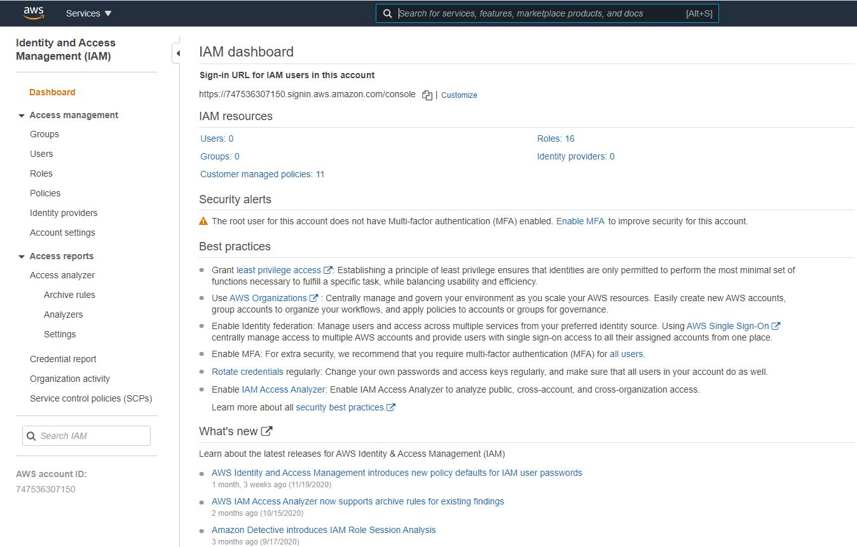

1. Navigate to IAM 🡪Policies and proceed to “Create policy”.

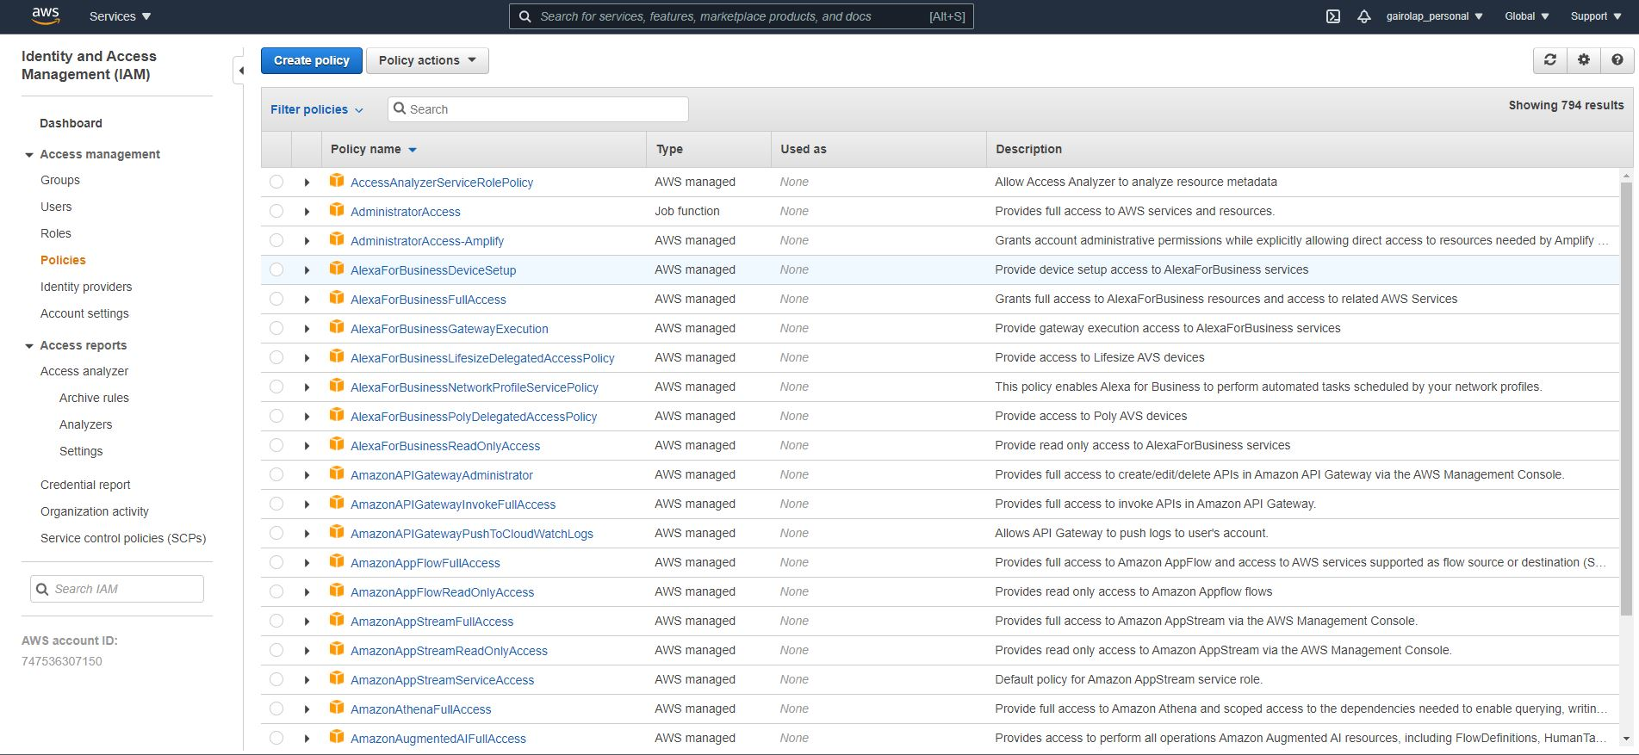

1. On the next screen, select “Secrets Manager” under Service.

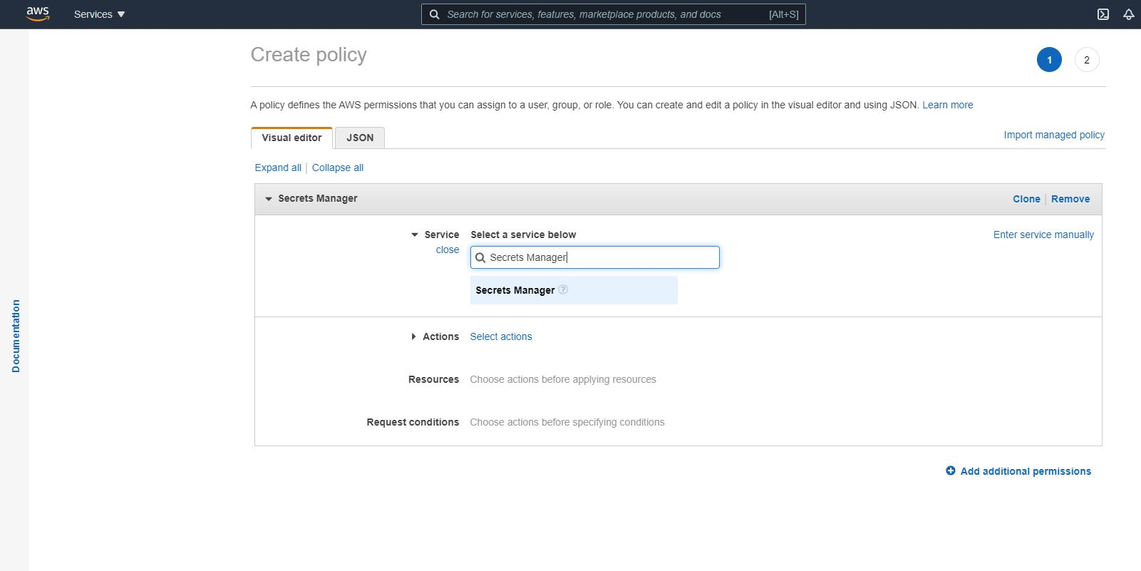

1. Select “Read” under Actions.

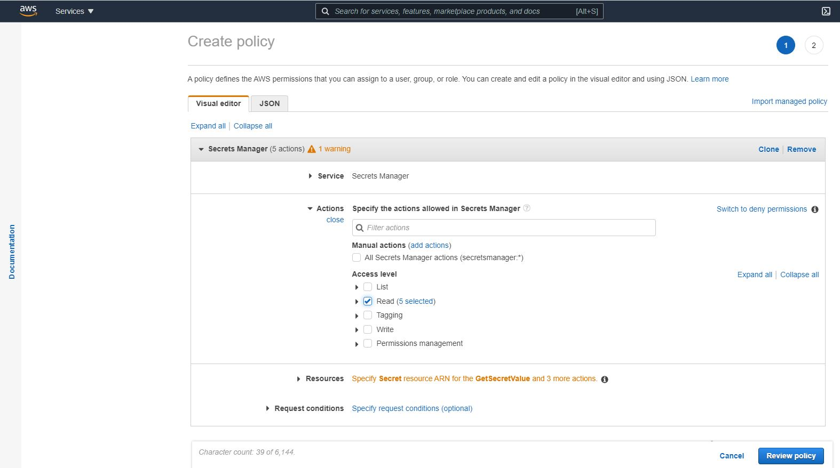

1. Under Resources add the ARN for the secret you want this policy to be created for and proceed to “Review policy”.

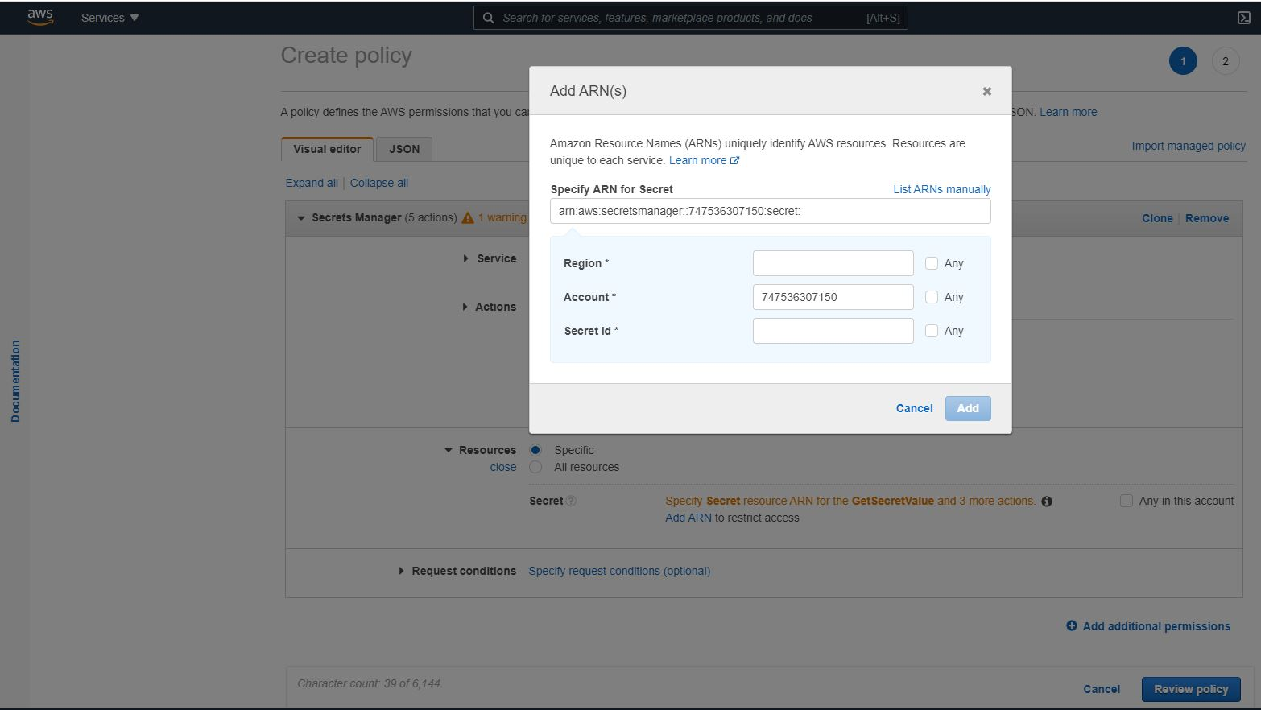

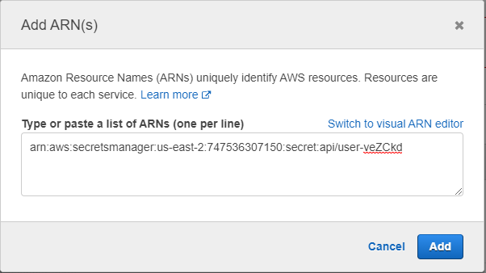

1. Give a suitable name and description for policy and proceed to “Create Policy”.

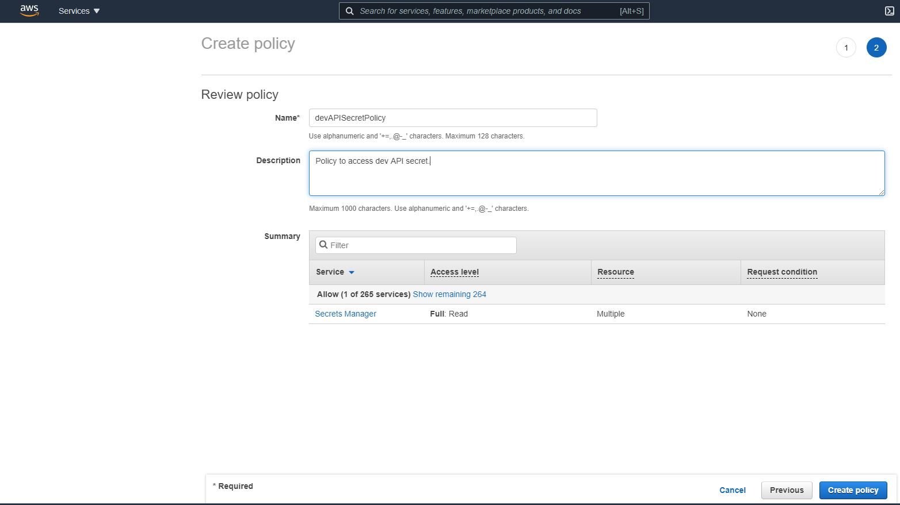

1. Policy gets created and one can search for the same in the list of policies.

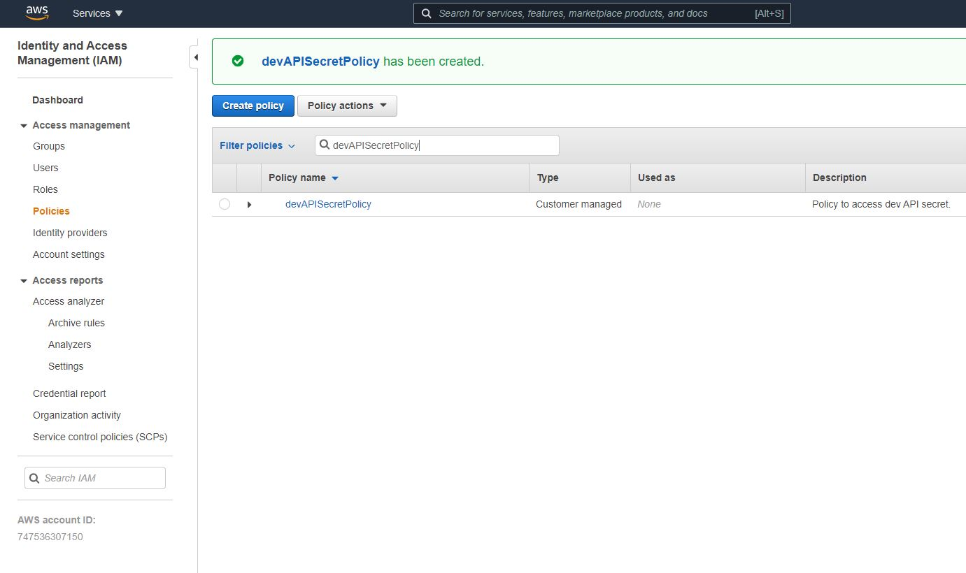

Create a new role and attach the policy created to the role.

1. Navigate to IAM 🡪 Roles and proceed to “Create role”.

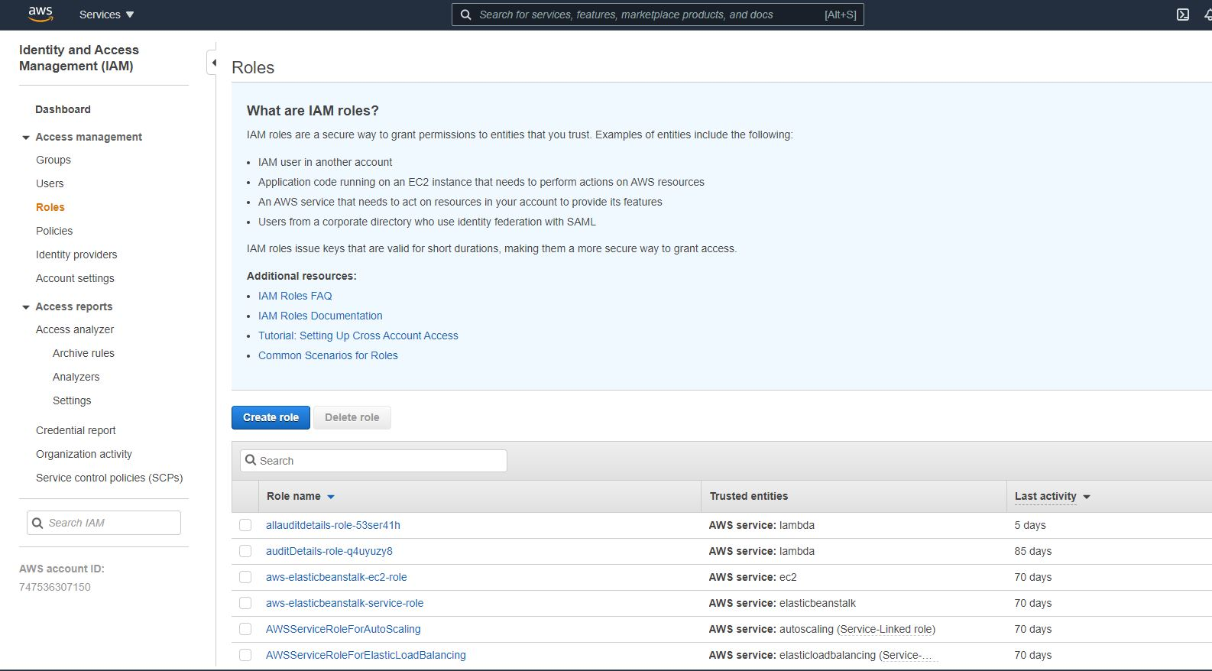

1. Under “Create role”, select Lambda as the use case as the role being created would be used by a lambda function and proceed to “Next: Permissions”.

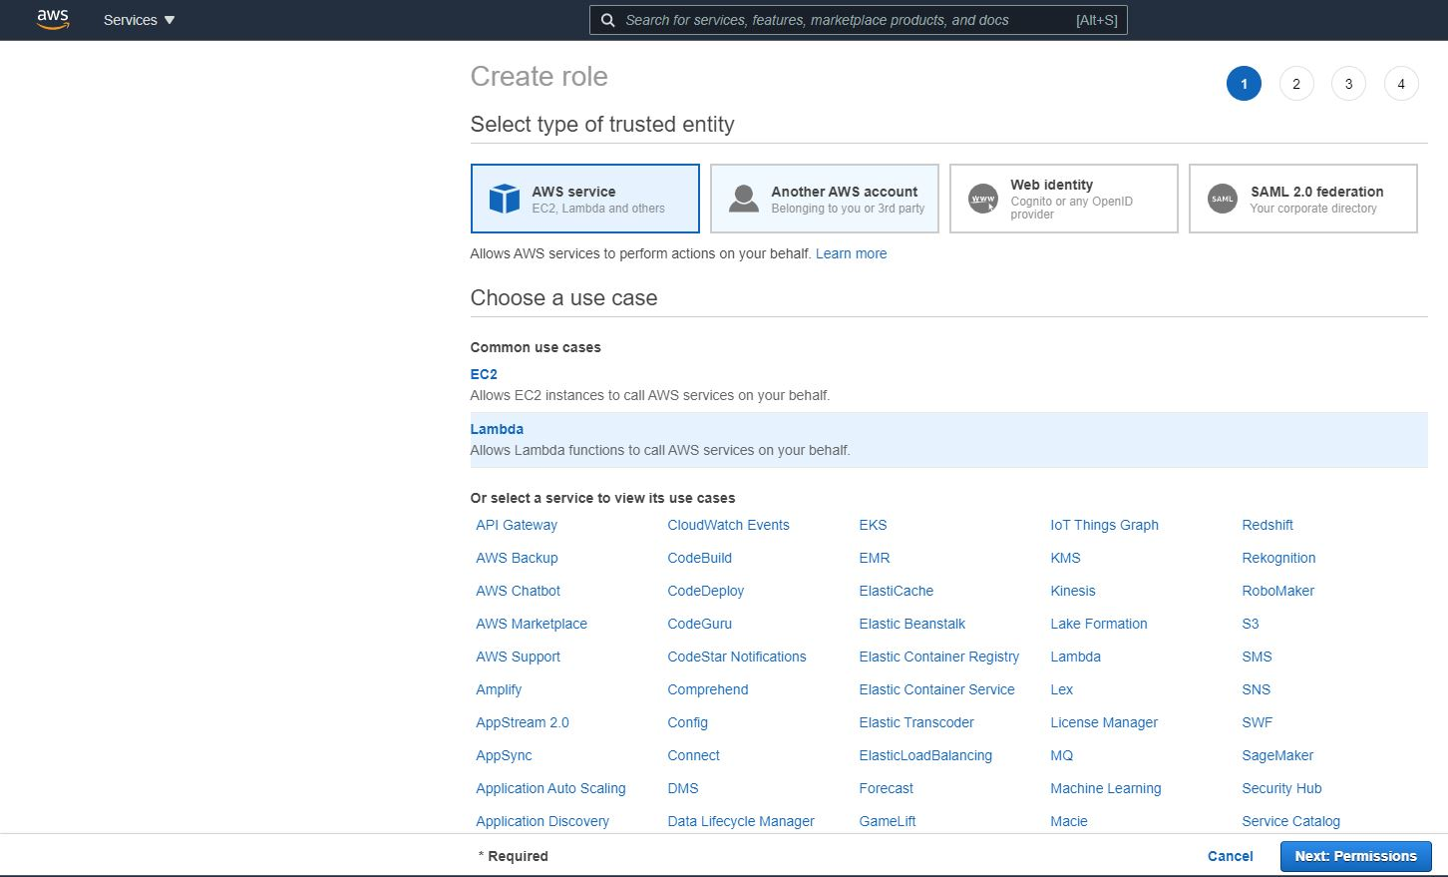

1. On the next page select the newly created policy from the list and proceed to “Next: Tags”.

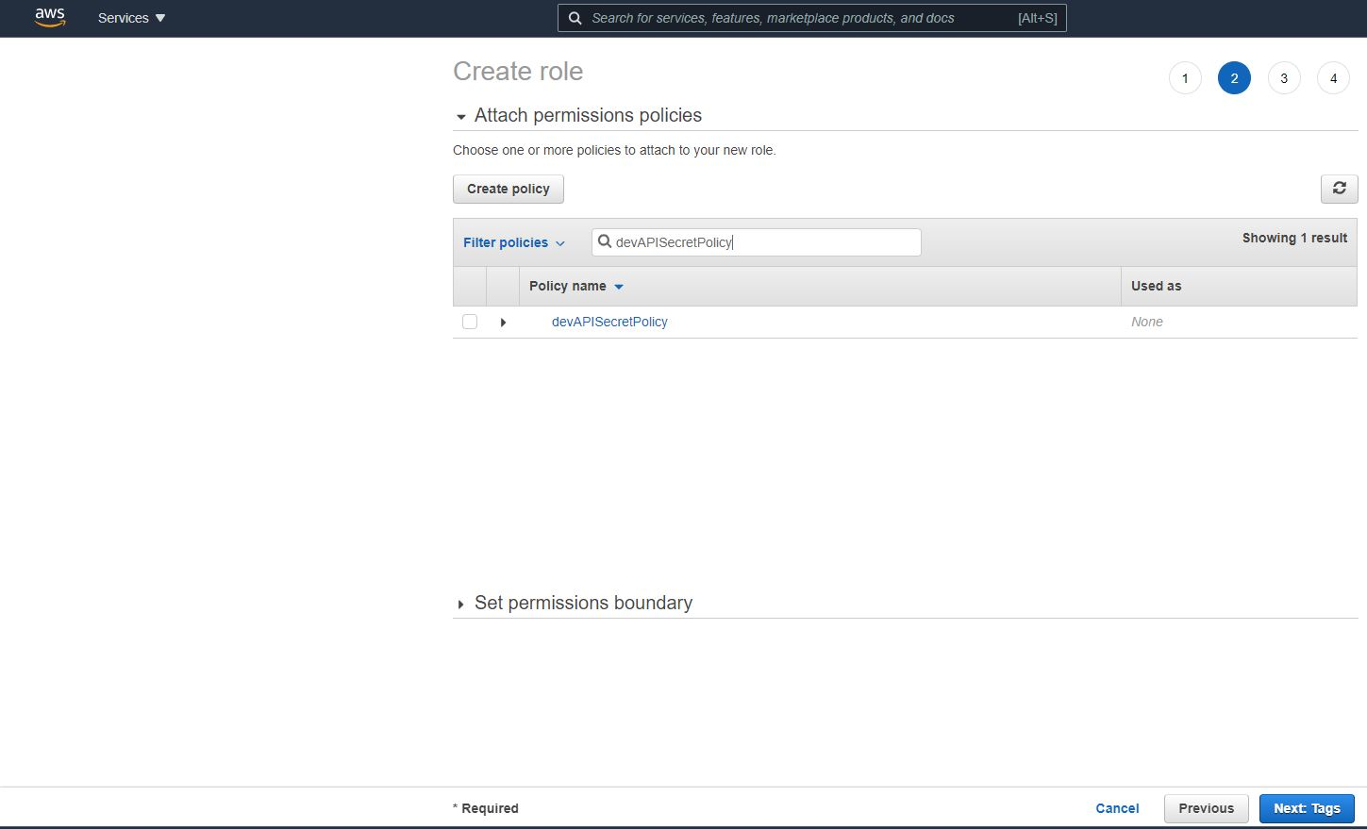

1. Skip adding tags on the next page and proceed to “Next: Review”.

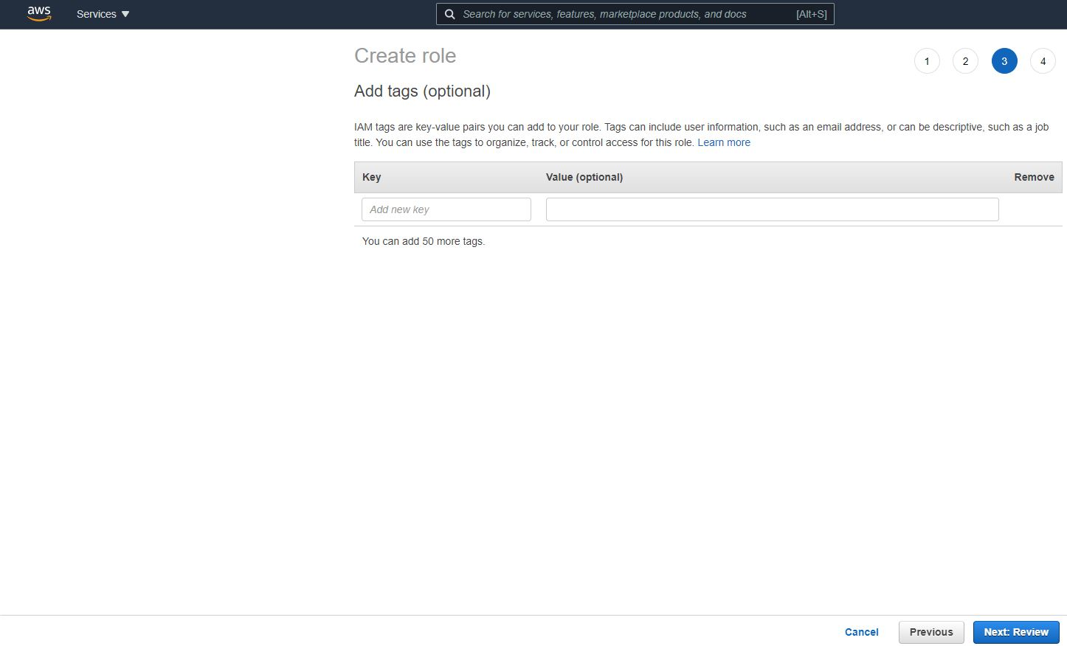

1. On the next page give a suitable role name and description and proceed to “Create role”.

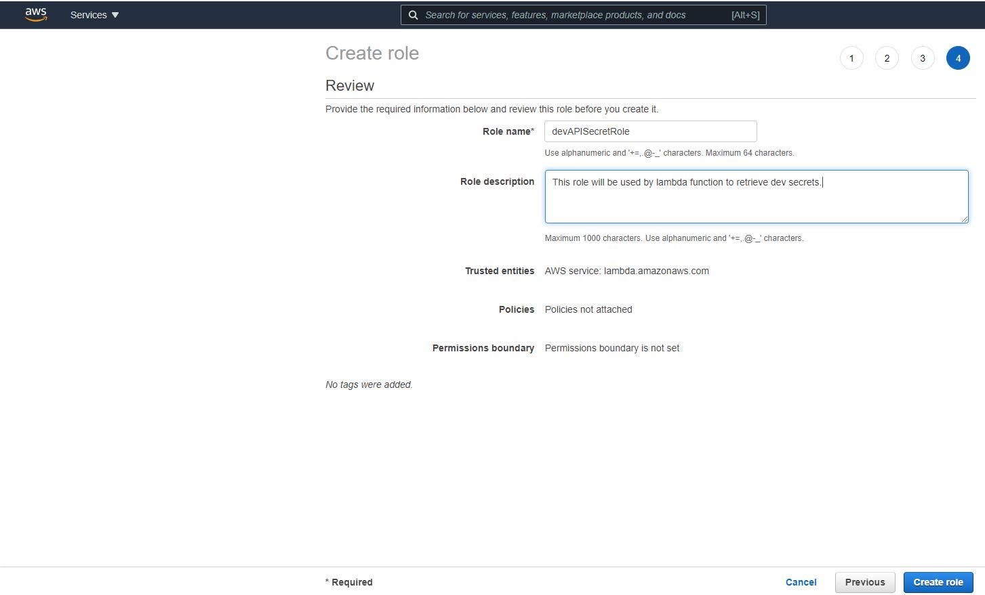

1. Role gets created and one can search for the same in the list of policies.



Create a lambda function to fetch the secret from AWS secret manager by assigning the role created above.

1. Navigate to lambda and proceed to “Create function”.

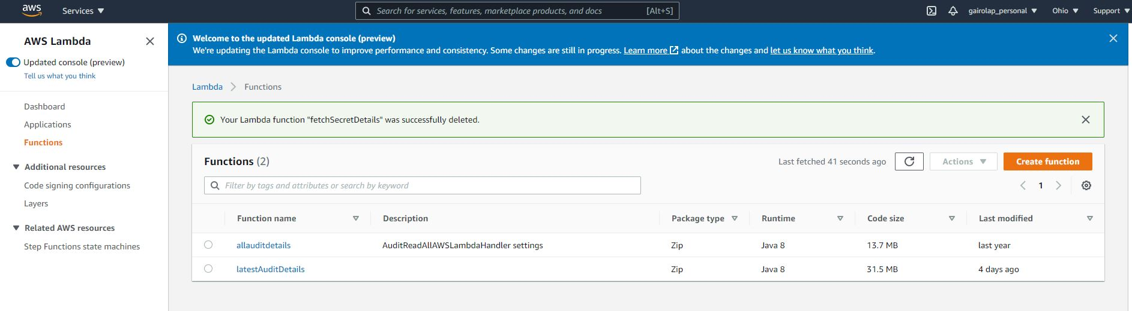

1. On the next screen under “Function name” provide the actual method name from the lambda function code that will be invoked for fetching the secret details. Under “Runtime”, select “Java 8” and under “Permissions”, select “Change default execution role” and opt for “Use existing role”. From the “Existing role” dropdown select the role created in the steps above. Proceed to “Create function”.

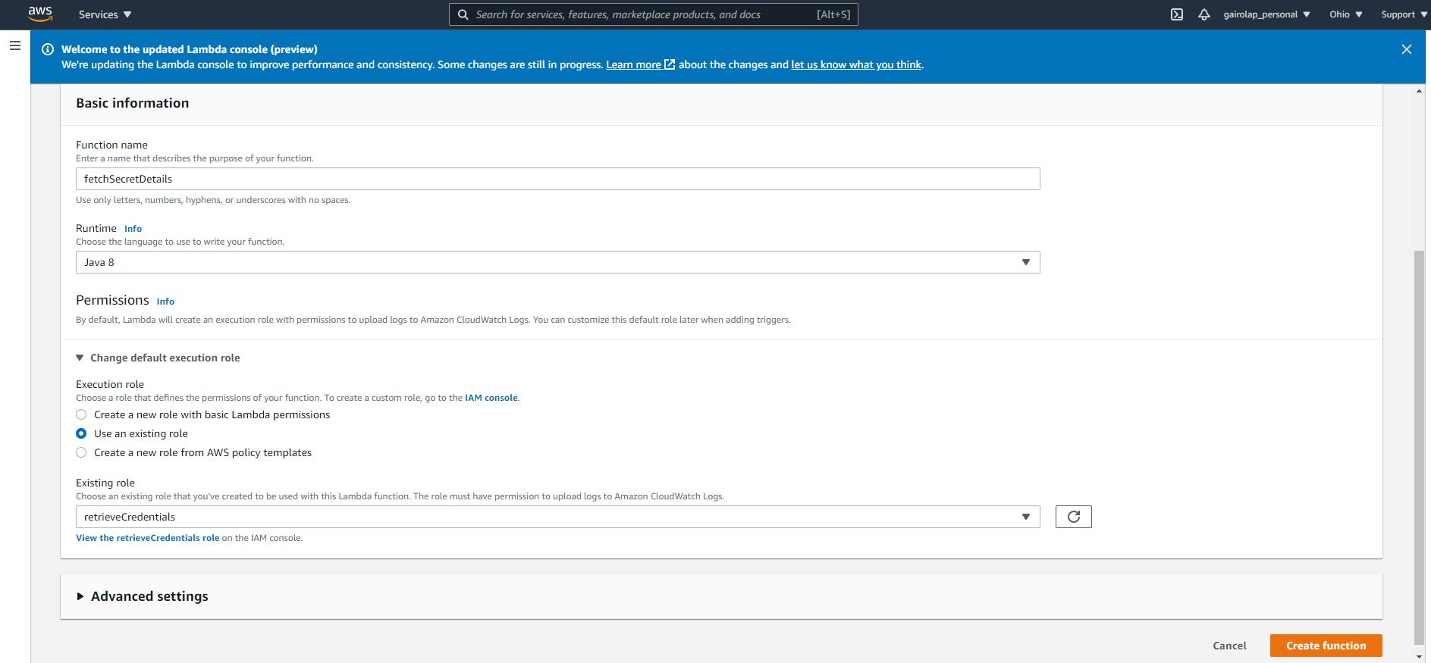

1. On the next screen, under “Code source”, upload the artifact using “Upload from”.

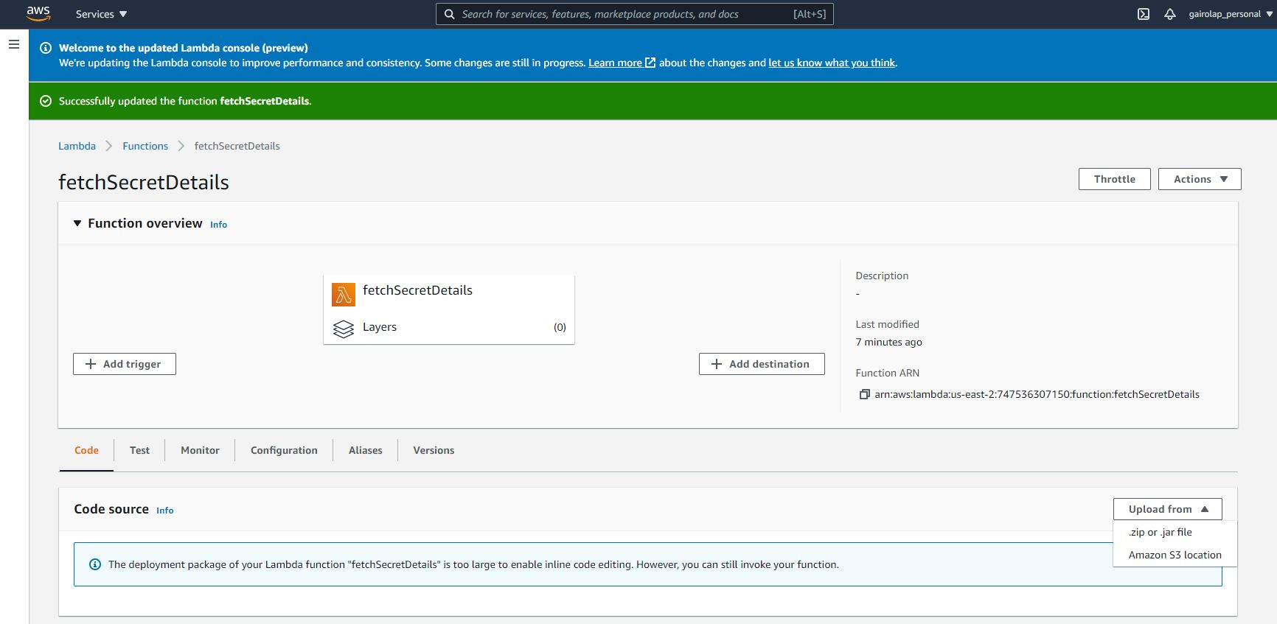

1. Edit the “Runtime settings” and provide the handler details. Handler you provide here is the one created as part of your lambda function code.

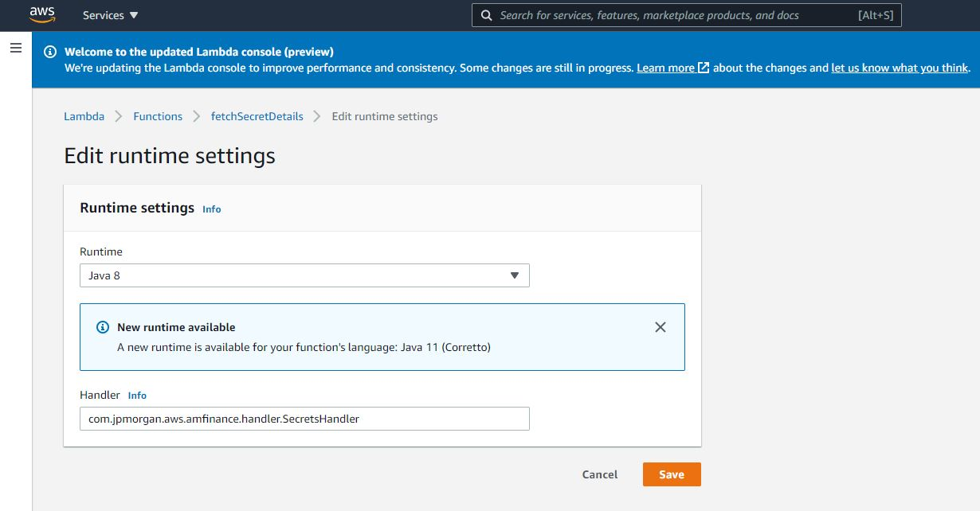

1. Next is to test the lambda function created. Navigate to “Test” tab on your screen. Let the “Template” default to “hello-world”. Give a suitable name for the event. Provide the sample JSON request you would like to use in order to test the function and proceed to “Create event”.

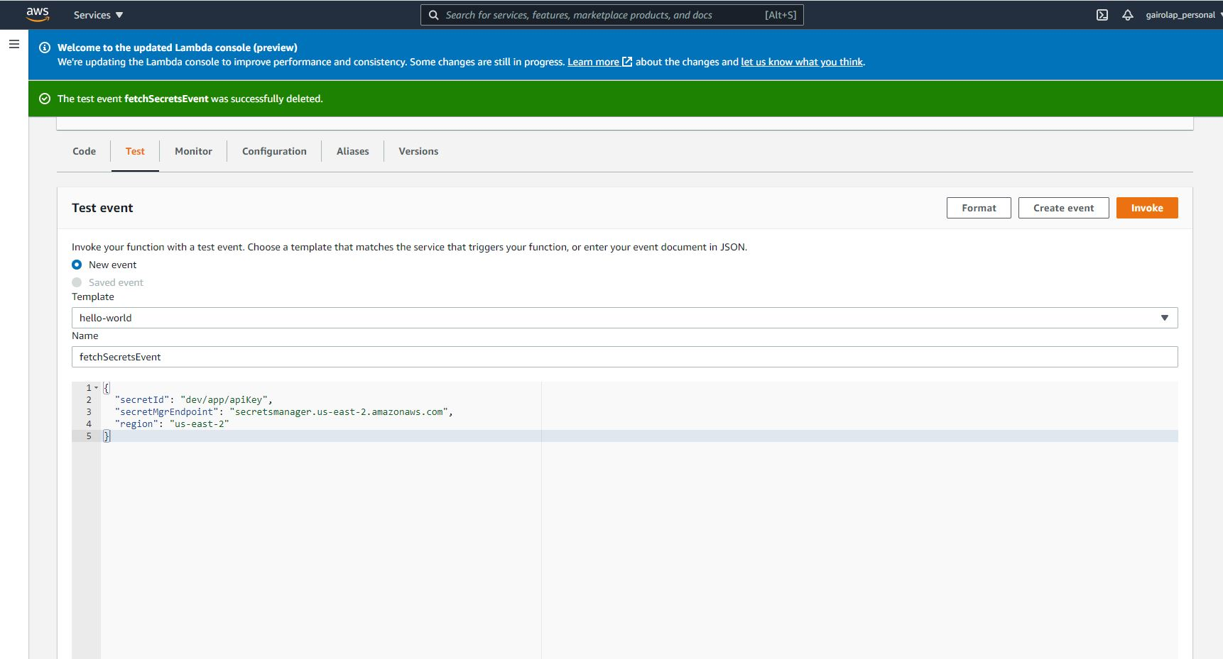

1. Once the test event is created, click on “Invoke” to test. Upon successful execution of lambda function you would see the secret details as part of your execution result.

